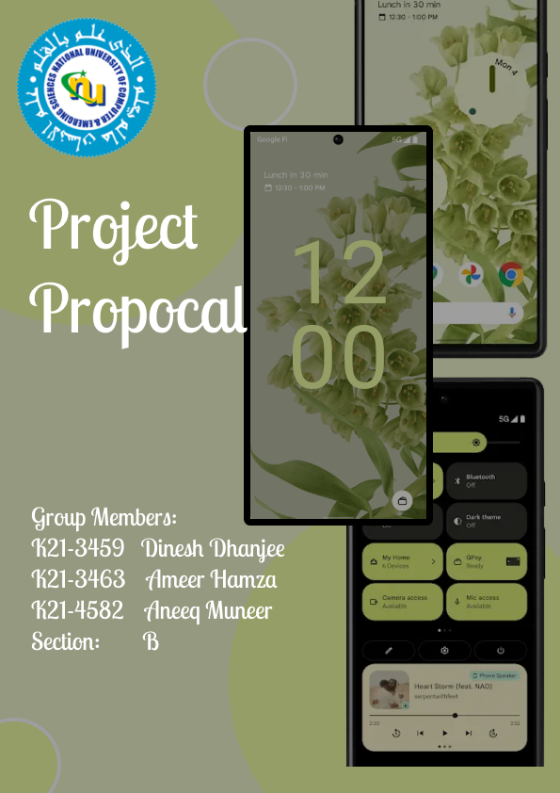

## Problem Statement:

## As the technology gets advance, it gets more expensive. People have to compromise either on budget or performance. Mostly people choose cheap devices which later became a hassle.

## Introduction:

The Android Emulator simulates Android devices on your computer so that you can test your application on a variety of devices and you can experience the same feature without the need of a physical device. The emulator provides almost all of the features of a real Android device.

## Solution:

Trying to accumulate money for your new expensive device! Well don’t worry we got you. With our ROA12 (Android emulator) you can experience the same behavior, performance and features of Android 12 on your available computer. You can experience the basic apps like calculator, messages app, contacts app, notes, clock app, setting, etc.

## Tools and Technologies

## Environment/IDE:

* Visual Studio 2022
* VS Code

## Additional Libraries

* SFML

## Concepts Covered

* OOP principles